Assignment 7
Bharat Unnati AI Fellowship
CodeXpert
Name: prathviraj Gowda

USN: 1CR22CD034

College: CMR INSTITUTE OF TECHNOLOGY

Assignment 7
Topic:
Student Marks Evaluation Using Nested if–else Statements

Objective
The objective of this program is to accept a studentʼs marks and determine the corresponding grade and result using nested if–else conditions. This helps in understanding decision-making logic in different programming languages.

1. Python Program
score = int(input("Enter the student's score: "))
if score >= 40: if score >= 85: print("Grade:
A") print("Result: Distinction") elif score >= 70: print("Grade: B") print("Result: First Class") elif score >= 55:
print("Grade: C") print("Result: Second Class") else: print("Grade: D") print("Result:
Pass") else:
print("Grade: F") print("Result:
Fail")
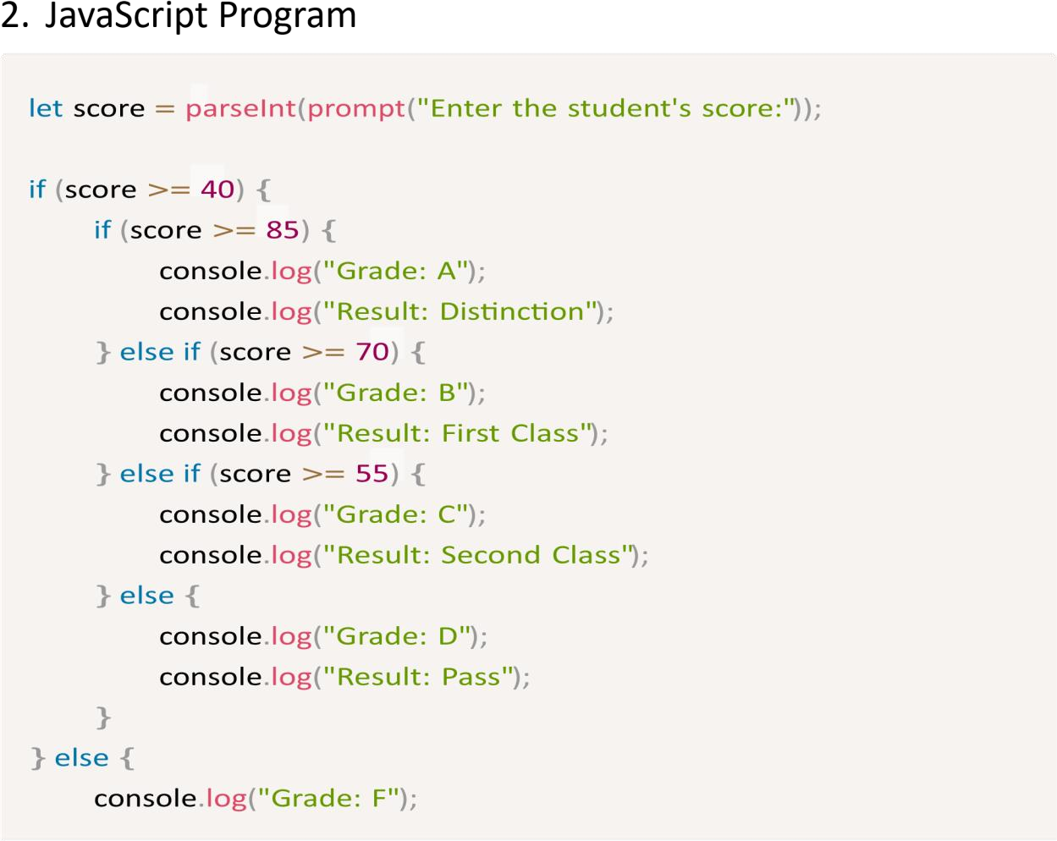
console.log("Result: Fail");
}

3. C++ Program
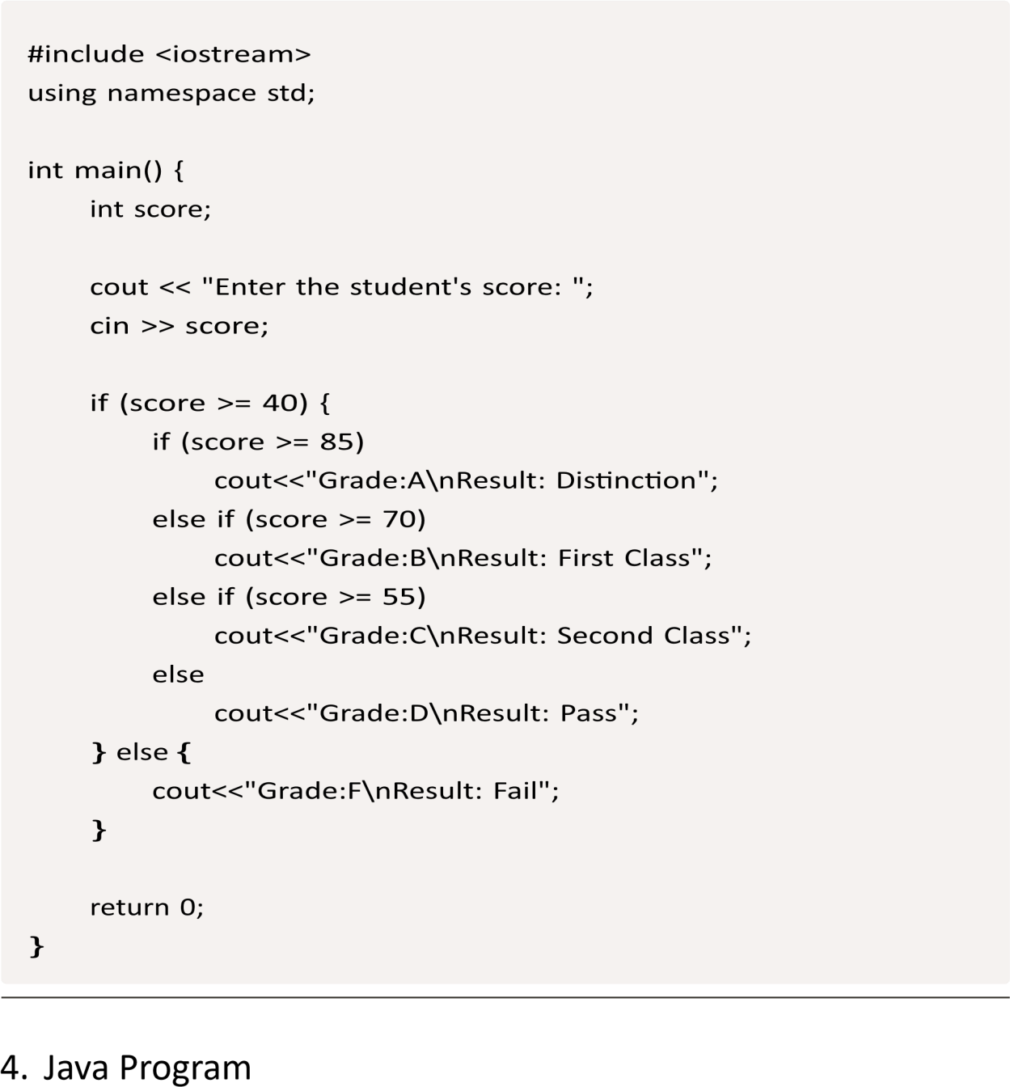
import java.util.Scanner;
public class StudentResult { public static void main(String[] args) {
Scanner input = new Scanner(System.in); System.out.print("Enter the student's score:
"); int score = input.nextInt();
if(score>= 40) { if(score >=
85)
System.out.println("Grade: A\nResult: Distinc
tion"); elseif (score >= 70)
System.out.println("Grade: B\nResult: First C
lass"); elseif (score >= 55)
System.out.println("Grade: C\nResult: Second Class");
else
System.out.println("Grade: D\nResult: Pass");
} else {
System.out.println("Grade: F\nResult: Fail");
}
input.close(); }
}

5. C Program
#include <stdio.h> int main() { int score; printf("Enter the student's score: "); scanf("%d", &score);
if(score>=40) {
if(score>= 85) printf("Grade: A\nResult: Distinction"); elseif(score
>= 70) printf("Grade: B\nResult: First
Class"); elseif(score >= 55) printf("Grade: C\nResult: Second Class"); else printf("Grade:
D\nResult: Pass");
} else { printf("Grade: F\nResult: Fail");
}
return 0; }

6. C# Program
using System;
class StudentResult { static void Main() {
Console.Write("Enter the student's score: "); int score =
Convert.ToInt32(Console.ReadLine());
if(score>= 40) { if(score >=
85)
Console.WriteLine("Grade: A\nResult: Distinct
ion"); elseif (score >= 70)
Console.WriteLine("Grade: B\nResult: First Cl
ass"); elseif (score >= 55)
Console.WriteLine("Grade: C\nResult: Second C
lass");
else
Console.WriteLine("Grade: D\nResult: Pass");
} else {
Console.WriteLine("Grade: F\nResult: Fail");
}
}
}

7. Kotlin Program
fun main() { print("Enter the student's
score: ") val score = readLine()!!.toInt()
if(score>=40) {
if(score>= 85) println("Grade: A\nResult: Distinction") elseif(score
>= 70) println("Grade: B\nResult: First
Class") elseif(score >= 55) println("Grade:
C\nResult: Second
Class") else println("Grade:
D\nResult: Pass")
} else { println("Grade: F\nResult: Fail")
}
}

Conclusion
Thisassignmentdemonstrates the use of nested if–else statements to evaluate student performance based on marks. The logic has been implemented consistently across multiple programming languages, improving understanding of conditional control structures.

